STUDY BRIEF

TEAM 2 (TargetEd MAnageMent Intervention)
Reducing stroke risk in African-American Men

Case Western Reserve University School of Medicine and Frances Payne Bolton School of Nursing
Principal Investigators: Martha Sajatovic, M.D., Department of Psychiatry
Carolyn Harmon Still, PhD, MSM, School of Nursing
Co-Investigator: Shirley Moore, PhD, RN, FAAN, Cheryl Killion PhD, RN,
Christopher Burant, PhD, Douglas Einstadter, MD, Sophia Sundararajan, MD
Study Funding: National Institute of Nursing Research (NINR)

Background:
Stroke is a leading cause of disability, death, and health resource use among Americans. Although U.S. stroke mortality rates have declined over the last decade, stroke deaths remain high for African-Americans (AAs) compared to non-Hispanic white Americans (NHWs). AAs have higher stroke rates, experience stroke at a younger age, have more disability, more complications, and slower recovery. Racial disparities in stroke outcomes are particularly high among AA men. High rates of hypertension and diabetes among AA contribute to stroke disparity.

Social determinants of health and other factors associated with stroke disparities in AA men include higher rates of smoking, obesity, social stressors, coping styles, unemployment and underemployment and health access issues. Once they have experienced a stroke, AA stroke survivors are likely to be discharged from acute care settings to home. However, informal home care may be inadequate in some cases to provide the support needed for AA men who have experienced a life-changing medical event.

The purpose of the TEAM psychoeducational approach is to reduce the unacceptably high rates of stroke and stroke complications in African-American (AA) men who have experienced mild deficit stroke or transient ischemic attack (TIA).

The intervention:
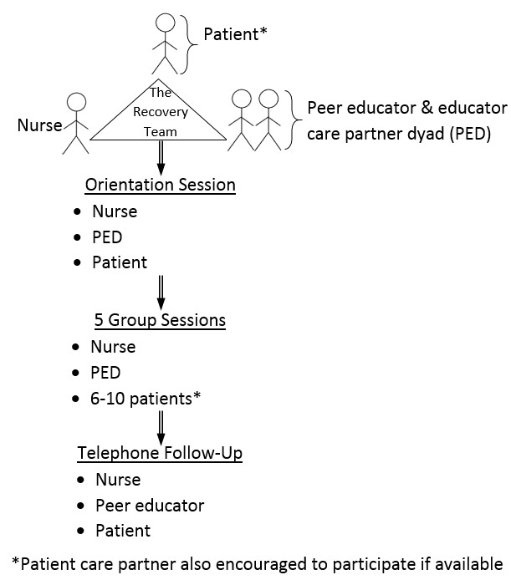
The TEAM intervention was developed by researchers at Case Western Reserve University (CWRU) to specifically engage and improve health outcomes in AA men at high risk for stroke.

TEAM is a nurse-led, person-centered, holistic intervention that takes advantage of existing strengths in AA families/communities. TEAM uses peer educator dyads (PEDs) to provide support and model behaviors. The PED consists of an AA man peer educator with experience in managing his own stroke risk and his care partner. A care partner is a family member, friend or other individual who is important in the AA man’s stroke recovery.

After an individual orientation session, the intervention will be delivered in five 60-minute group sessions with 6-10 stroke survivors (and their care partners as applicable) held approximately every 2 weeks. It will be followed by six brief telephone calls conducted every 2 weeks for 12 weeks after the conclusion of the group sessions and made in alternating order by the nurse and the peer educator.

Please contact: Michaela Broadnax at 1-888-817-0004 or Michaela.Broadnax@uhhospitals.org

